985 Woodbine Avenue
Community Consultation Meeting

Virtual Meeting Details

Monday, May 6, 2024 from 6:00 p.m. to 8:00 p.m.

Join online by Webex
Visit www.toronto.ca/CPconsultations for the registration link and instructions on how to join. We encourage you to join ten minutes before 6:00 p.m. to allow time to log on.
Join by Phone
Dial 416-915-6530 and enter
Meeting ID: 2634 640 7203
Passcode: 94734437
If joining by phone, press
*3 to raise/ lower your hand.

Proposals
The City of Toronto has received a resubmission of an application to amend the Zoning By-law at 985 Woodbine Avenue, which substantially revises the original proposal.
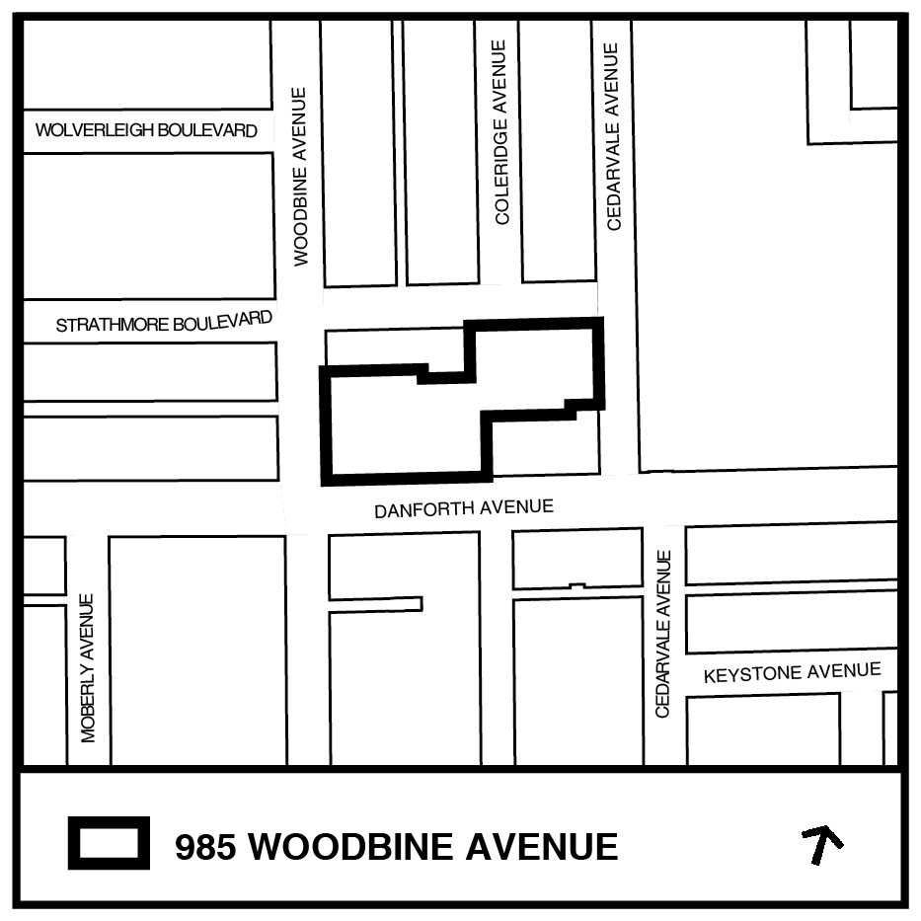

The revised proposal includes a 35-storey residential building with retail uses at-grade at the intersection of Woodbine and Danforth Avenues. A 10-storey residential building is proposed at the northeast end of the site. The development includes 646 residential units, including 14 replacement rental units, 152 vehicular parking spaces and 740 bicycle parking spaces

Please join us at this Community Consultation Meeting to hear next steps for this application and to provide feedback.

More Information
For more information on this proposal, please refer to the contact information below or refer to the City’s Application Information Centre at the following link: https://www.toronto.ca/city-government/planning-development/application-details/?id=4533699&pid=269032

Additional Participation Information
Join by Phone:
Before the meeting: Submit your comments in advance by contacting the City Planning Staff or the Councillor’s Office.
To join the meeting: Dial 416-915-6530 and enter Meeting ID: 2634 640 7203, Passcode: 94734437

Participants by phone will be able to ask live questions during the meeting by dialing *3.
Join Online:
The session will take place on Monday, May 6 from 6:00 to 8:00 pm.
A link will be provided on the City Planning Consultations Webpage at http://www.toronto.ca/CPconsultations before the session to be used for joining the meeting Online.
For more information about how to join the meeting and how to participate visit www.toronto.ca/HowToEngageOnline.

If you are unable to participate in the meeting you can contact City Planning Staff or the Councillor’s Office with your comments and questions using the contact information provided below:

Contact Information

Steven Barber Councillor Brad Bradford
Senior Planner Ward 19 Beaches-East York Councillor
City Planning Division City of Toronto
Steven.Barber@toronto.ca Councillor_Bradford@toronto.ca
416-338-8567 416-338-2755

Notice to correspondents
Information will be collected in accordance with the Municipal Freedom of Information and Protection of Privacy Act. With the exception of personal information, all comments will become part of the public record.

