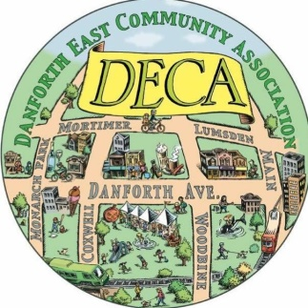

Danforth East Community Association

Young Leaders Scholarship
The Young Leaders Scholarship will award $2,000 to a deserving high school student entering post-secondary studies or training who is involved in improving their communities.
The Danforth East Community Association (DECA) was formed by a group of neighbours in 2007. Our vision is to make our pocket of the city a more vibrant, walkable and safe place. Since then, we have created the East Lynn Park Farmers’ Market, launched the Danforth East Arts Fair, incubated and run commercial revitalization initiatives along the Danforth including the pop-up shops, run a highly active adopt-a-tree program throughout the area, and raised $30,000 towards sponsoring Syrian refugees, among many other things.
_________________________
To be eligible, you must:
- Be entering your first year of post-secondary education or training in fall 2019
- Live or go to school within DECA boundaries (Main Street east, Lumsden/Mortimer north, Monarch Park west and the train tracks to the south)
- Be actively working to improve your school and/or neighbourhood in some demonstrable way
SUBMIT YOUR COMPLETED APPLICATION TO: INFO@DECA.TO
DEADLINE: June 16, 2019
Application Guidelines
1. BRIEF BIOGRAPHY

Answer the following questions:

a. What high school do you attend?
b. Where do you plan on attending post-secondary education? What do you plan on studying/training for?
c. What people or events have inspired you?
d. In what ways do you hope to continue to contribute to your community, during and after post-secondary education?

2. ESSAY OR VIDEO

You must submit an entry that addresses the following:

Describe leadership you have taken in your school and/or community that involve promoting, supporting and celebrating any of the following: diversity and inclusion, environmentalism, youth or seniors, mental wellness, civic engagement, and/or community building.

You may do this by choosing one of the following options:

a) short essay (up to 500 words)
b) video (max. 5 minutes with 150-word summary). Include a link to your online video.

3. ONE REFERENCE LETTER

Please have your reference provide a letter which outlines your school and/or community involvement. At least one reference letter must be from a representative of your school or a community agency.

Reference name | Relationship to you | Telephone number

4. CONTACT INFORMATION

NAME:
ADDRESS:
EMAIL ADDRESS:
PHONE NUMBER:

